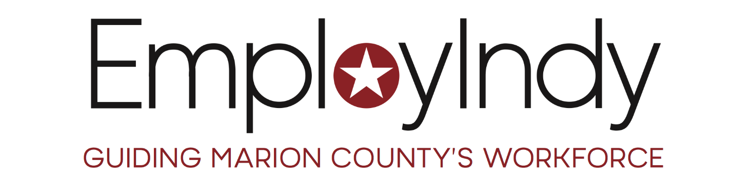

NOTIFICATION OF REQUEST FOR PROPOSALS

Provision of
YES INDY SERVICES

Issued September 1, 2020

Proposals must be received no later than 4:00 pm EDT
Friday, October 16, 2020

Contract Period:
January 1, 2021 – December 31, 2021
With option to extend for up to two additional years

RFP# 2020-003

EmployIndy
PNC Center
101 W. Washington St., Suite 1200.
Indianapolis, IN 46204
(317) 639-4441

EmployIndy, its programs, and contract service providers are Equal Opportunity employers/programs.
Auxiliary aids and services are available upon request to individuals with disabilities.

Table of Contents

Introduction 3
- Purpose 4
- YES Indy Service Provision 5
  - Who are Opportunity Youth 5
  - Framework 6
    - Recruitment & Engagement 6
    - Empowerment 7
    - Employment 8
  - Service Elements & Delivery 8
  - Career Navigation 12
  - Values 13
  - Responsibilities 14
    - Funding Compliance 14
    - Data Collection & Outcome Evaluation 14
    - Quality Assurance 15
    - Community of Practice 15
    - Insurance 15
- Contract Specifications 16
  - Governing Authority 16
  - Contract Type, Program Period, and Available Funding 16
  - Technical Qualifications 16
  - Terms & Conditions 17
- Proposal Requirements 18
  - Proposal Timeline 18
  - Proposal Submission 20
  - Formatting 20
  - Required Proposal Outline and Components 20
    - Proposal Cover Sheet 20
    - Organizational Capability and Qualifications 20
    - Service Delivery Plan 21
    - Diversity, Equity and Inclusion 22
    - Budget & Budget Narrative 23
- Evaluation and Selection Criteria 24
- Glossary of Terms 26
- Attachments
  - Attachment A: Opportunity Youth in Marion County 31
  - Attachment B: Marion County Youth Employment System 32
  - Attachment C: YES Service Elements and Delivery Plan 33
  - Attachment D: WIOA Titles I-IV 34
  - Attachment E: Funding Source Assessment 35
  - Attachment F: Projected Outcomes 38
  - Attachment G: Budget Summary 40
  - Attachment H: YES Indy Logic Model 41

Introduction

EmployIndy, the workforce development board for Marion County, is working to meet regional and statewide workforce development goals by removing barriers to quality employment as well as connecting individuals to entry-level positions. As part of the workforce ecosystem, EmployIndy invests federal, state, and philanthropic funds to help job seekers access employment, education, training and supportive services to succeed in the labor market and to match employers with the skilled workers they need to compete in the global economy. Regionally, there is a high demand for skilled workers in industries such as technology, manufacturing, logistics, and financial services, however, with only 42% of Central Indiana residents holding post-secondary credentials, there is a gap between available skilled workers and these jobs. To combat these numbers, EmployIndy is working with regional partners to detect gaps in employer needs and partnering with WorkOne locations and community-based organizations to provide access to training to create a pipeline of talent to fill these positions.

EmployIndy’s vision for this critical economic development work in Central Indiana is outlined in the organization’s Strategic Plan (2017-2022) and centered on three primary objectives:

      - Address employers’ need for a strong pipeline of entry-level workers;
      - Provide opportunities and outline pathways by which young adults (both in school and out of school) can actively participate in the workforce;
      - Meet the needs of residents living in areas of the city that are most affected by poverty and unemployment;

EmployIndy meets its obligations and strategic commitments through a mix of direct service delivery, management of contracted entities engaged to deliver specialized services, and informal coordination of multiple, diverse partners present in Marion County’s workforce ecosystem.

Refer to the EmployIndy website, Resources page at https://employindy.org/resources/ for details regarding the Strategic Plan and Year One Action Plan.

The term “ecosystem” is intentionally and consistently used by EmployIndy to reinforce the reality that meeting the diverse needs of job seekers and employers in Marion County requires healthy interaction between a community of partnering entities – including each of the WIOA Required Partners, the City of Indianapolis, community-based providers, economic development professionals working at the county level and on behalf of specific neighborhoods, employers of every size from every sector of the economy, diverse education providers working with youth at every academic level, occupational trainers, and many more.

With emphasis on the ABC Method – Any Job, Better Job, Career – EmployIndy drives growth in Indianapolis by investing in innovative jobs-to-careers strategies that ensure youth and young adults have access to career pathways where they gain the skills they need to enter into jobs, and ultimately careers, that Indianapolis' employers have available and are looking to fill.

EmployIndy is deliberately deepening its effort by aligning resources and services in five high-priority neighborhood clusters in the Near East (46201), North West (46208), Mid-North (46205), North East Corridor (46218), and Far East (46235). In these neighborhood clusters and beyond, an estimated 80,000 Marion County residents are unemployed, under-employed or marginally attached to the workforce. EmployIndy is increasingly applying an intentional, place-based approach to delivering education, training, employability skills, and work-based learning at the neighborhood level to advance strong and supportive communities. In doing so, we believe we have the responsibility and capability to serve as a catalyst for community-level progress by strengthening the public workforce system and our local network of employment and training service providers.

Purpose

There are an estimated 30,000 Opportunity Youth, ages 16-24, disconnected from education and employment in our community due to a variety of barriers that range from financial or housing issues to involvement with the criminal justice system. This number increases annually to include youth who do not complete high school, and young adults who do not go on to college or persist in post-secondary education. Annually, EmployIndy estimates that 5,445 youth and young adults fall out of the educational system in Marion County. Refer to Attachment A, Opportunity Youth in Marion County.

EmployIndy is committed to providing career information and substantive employment opportunities for youth and young adults in our city to prepare for the jobs of the future. From exposure to industries and employers driving our local economy, to paid opportunities where youth can earn and learn, EmployIndy ensures that youth and young adults make smart choices about their education and careers. We operate and enhance programs to embark on career pathways, beginning with high school graduation or equivalency, to post-secondary education, summer jobs, and the removal of barriers to employment for access to in-demand jobs that require more than a high school diploma but less than a four-year baccalaureate degree.
EmployIndy is committed to create a diversified, equitable, and inclusive multicultural workplace environment throughout our ecosystem to create an authentic community.
COVID-19 has led to the dislocation of tens of thousands of workers throughout Marion County. The shelter in place order left many businesses closed and residents out of work. Young people are likely to be disproportionately affected by virus-related layoffs. The top industries from which workers were dislocated include those with a concentration of lower-wage occupations: accommodation and food services; retail trade; admin and support and waste management and remediation services; health care and social services; and manufacturing. In fact, youth and young adults have been impacted at more than twice the unemployment rate of adults, with more than a quarter of workers between the ages of 16-24 out of work. In addition to the dislocation of workers, the virus has also disrupted in-person services throughout Indianapolis, including the YES Indy network. Moving forward, EmployIndy is dedicated to supporting strategies of engagement that transcend the need for in-person contact so that the youth of Marion County receive the services they need regardless of the state of the pandemic.
The purpose of this Request for Proposal (RFP) is to solicit proposals from qualified entities providing programs and services which respond to the unique needs of Opportunity Youth experiencing significant barriers to education, training, and employment.

YES Indy Service Provision

Who are Opportunity Youth?
In partnership with EmployIndy, the YES Indy service providers will be responsible for recruiting and serving youth and young adults. Eligibility for participating youth and young adults shall be determined at the point of enrollment and shall not change during that period of participation. The basic eligibility criteria are outlined below:

- Youth and young adults must be out-of-school and must not be enrolled or attending a secondary or post-secondary school.
- Youth cannot be younger than 16 and young adults must be under 25 years of age at the time of enrollment.
- Male participants 18 years or older must be registered with the Selective Service System in order to be enrolled as a WIOA participant.
- Youth must also have at least one of the following barriers:
  - Be a high school dropout;
  - Be of compulsory age for attending school, but have not attended school for at least the most recent complete school calendar quarter;
  - Be an individual who is or has been involved with the juvenile or adult justice systems;
  - Be homeless or former foster youth;
  - Be pregnant or parenting;
  - Have a disability;
  - Have a secondary high school diploma, be low income, and either basic skills deficient or an English language learner; and/or
  - Be low income and need additional assistance to enter or complete an educational program or to secure and hold employment.
- Opportunity Youth must be a Marion County resident in order to be enrolled into YES ETO. Opportunity Youth outside of Marion County may be enrolled into WIOA.

There are multiple ways to determine low income for youth and young adults including:

- The youth lives in an area that is identified as a high poverty area. An area of high poverty is a county or census tract that has a poverty rate of 30% or higher;
- At the time of enrollment in the program or in the previous six months, the family received or was eligible to receive SNAP, TANF, SSI or any state or local income-based assistance;
- The total family income is below the higher of the poverty level or 70% of the lower living standards during the six-month period prior to enrollment in the program;
- The youth is homeless as defined by the Violence Against Women Act of 1994 or the McKinney-Vento Homeless Assistance Act;
- The youth or a family member is eligible for free or reduced lunches at school. This primarily applies to in-school youth;
- The youth is a foster care youth or has aged out of foster care; or
- The youth is disabled and their personal income (not family income) is below the higher of the poverty level or 70% of the lower living standards during the six-month period prior to enrollment in the program.

Framework
The Youth Employment System (YES Indy) is a systems approach to delivering comprehensive services to Opportunity Youth. EmployIndy works closely with YES Indy service providers to integrate a set of foundational elements rooted in national best practices for serving Opportunity Youth and ensure that services are available along a continuum at multiple community access points. For more on the YES Indy Framework and Logic Model, please review Attachments B and H. Specifically, a youth’s pathway through this continuum is illustrated in Attachment B, Marion County Youth Employment System.

Recruitment and Engagement
EmployIndy supports engaging Opportunity Youth in a number of ways; through funding agencies, incubating and overseeing the development of the Re-engagement Centers (RECs), accepting referrals from the Indiana Department of Corrections and other agencies, utilizing the WorkOne as a referral source, and ensuring access to a Mobile YES Provider.
To increase outreach and recruitment of Opportunity Youth, EmployIndy has worked with the strategic communications firm VOX Global. VOX held focus groups with Opportunity Youth and service providers to review existing programs in our community and analyzed best practices in other markets. A comprehensive report including observations and initial programmatic and communications recommendations was compiled to help EmployIndy increase enrollment, retention, and success in YES Indy among Opportunity Youth.
These recommendations of programmatic changes to be made to increase recruitment and retention, including: utilizing the most popular social media and online platforms to advertise YES Indy Services; offering “micro-celebrations” to participants once they’ve reached a milestone to keep them engaged; providing more intense wrap-around services and incentives to opportunity youth between the ages of 18-21 as they are the largest age group of our opportunity youth population, yet the least likely to possess a growth mindset to self-select for education and workforce services without incentives.
This also included the launch of an interactive YES Indy microsite on June 24, 2019 which provides local youth and young adults an outlet to connect to YES Indy providers. EmployIndy’s communications team has also launched social media advertisements targeted at the population we are striving to serve, directing them to the new website, which has had nearly 11,400 views since its launch. Advertisements have been posted on the most popular outlets for this demographic - Instagram, Facebook, YouTube and Pandora. With nearly 5 million ad impressions generated across platforms, the campaign raised significant awareness of YES Indy. The nearly 10,000 social engagements and over 9,000 link clicks helped drive brand recognition and educate audiences of the program.

EmployIndy takes these measures and leads recruitment efforts because across the country and in our local market, the lament of providers is that they are unable to find the young adults who are disconnected from education and employment, and WIOA and federal funding sources significantly limit outreach and recruitment efforts. That being said, YES Indy service providers still have a significant role to play in recruiting youth in their community at the grassroots level by being deeply embedded in and connected to their own neighbors and community members, spreading the word wherever possible through their presence and services.

Empowerment
EmployIndy assists the YES Indy Network in delivering the 14 Youth Elements in a variety of ways that range from offering Power Huddle experiences, Job Ready Indy badges (jobreadyindy.org), connections to local partners, community of practice meetings to build up the quality of service delivery and offer continuous improvement opportunities, and more.
EmployIndy most recently developed Talent Bound (www.talentbound.org), another service that is available to the YES Indy service providers. The vision of Talent Bound is that Indy youth and young adults actively pursue integrated academic and career experiences that empower them to follow career pathways that lead to economic mobility and future prosperity. EmployIndy leverages its network of businesses to engage young adults in a continuum of real-world work experiences.
YES Indy Service Providers ensure that service delivery of the 14 youth elements (described in section III.c.) are high-quality, relevant, and innovative. Career Navigators build relationships with young adults and work with them often to offer them new opportunities and empower them to find a positive trajectory for their career and life.

Employment
EmployIndy helps youth gain employment through the EmployIndy Talent Solutions team and specifically via the Talent Network. Opportunity Youth are a hidden and elusive demographic, yet a critical population for closing critical workforce shortages. As young people access the essential services aimed at giving power to their career goals via YES Indy (described below in section III.b.), EmployIndy will support providers’ existing efforts in matching job ready participants to available employment opportunities. EmployIndy values and respects the existing employer partner relationships of our service providers. In an effort to increase placement opportunities within the YES Indy network, we seek to align and augment employment opportunities on behalf of the system.
This RFP seeks YES Indy service providers who will partner closely with EmployIndy, and an integrated network of fellow YES Indy providers, to strongly prepare a talent pool of Opportunity Youth for placement through their own efforts or EmployIndy Talent Solutions.

- Service Elements & Delivery
Providers operating within the EmployIndy YES framework will be selected based on their demonstrated ability to offer comprehensive services to young adults as they move along their journey from Engagement to Employment. Providers must incorporate fourteen (14) service elements required as part of the Workforce Innovation and Opportunity Act and as identified in a participants Individual Service Strategy (see below) to successfully achieve employment.

- Tutoring, study skills training, instruction, and evidence-based dropout prevention and recovery strategies that lead to completion of the requirements for a secondary school diploma or its recognized equivalent (including a recognized certificate of attendance or similar document for individuals with disabilities) or for a recognized postsecondary credential;
- Alternative secondary school services, or dropout recovery services, as appropriate;
- Paid and unpaid work experiences that have, as a component, academic and occupational education, which may include –
  - Summer employment opportunities and other employment opportunities available throughout the school year;
  - Pre-apprenticeship programs;
  - Internships and job shadowing; and
  - On-the-job training opportunities.
- Occupational skills training, which may include priority consideration for training programs that lead to recognized postsecondary credentials that are aligned with in-demand industry sectors or occupations in the local area;
- Education offered concurrently with, and in the same context as, workforce preparation activities and training for a specific occupation or occupational cluster;
- Leadership development opportunities, which may include community service and peer-centered activities encouraging responsibility and other positive social and civic behaviors, as appropriate;
- Supportive services (which are services that are necessary to enable an individual to successfully participate in workforce development activities. Examples include but are not limited to
  - Linkages to community services;
  - Assistance with transportation; Assistance with child care and dependent care;
  - Assistance with housing;
  - Needs-related payments, as described below;
  - Assistance with educational testing;
  - Reasonable accommodations for individuals with disabilities;
  - Legal aid services;
  - Referrals to health care;
  - Assistance with uniforms or other appropriate work attire and work-related tools, including such items as eyeglasses, protective eye gear and other essential safety equipment;
  - Assistance with books, fees, school supplies, and other necessary items for students enrolled in postsecondary education classes; and
  - Payments and fees for employment and training related applications, tests, and certifications.;
- Adult mentoring face-to-face for the period of participation and a subsequent period, for a total of not less than 12 months;
- Follow-up services for not less than 12 months after the completion of participation, as appropriate; youth or young adult has the right to opt out of follow-up services.
- Comprehensive guidance and counseling, which may include drug and alcohol abuse counseling and referral, as appropriate;
- Financial literacy education which refers to activities that provide youth with the knowledge and skills that they need to achieve long-term financial stability. Financial literacy education encompasses information and activities on a range of topics, such as creating budgets; setting up checking and saving accounts; managing spending, credit, and debt; understanding credit reports and credit scores; and protecting against identity theft.;
- Entrepreneurial skills training which provides the basics of starting and operating a small business. Examples of approaches to teaching youth entrepreneurial skills include:
  - Entrepreneurship education that provides an introduction to the values and basics of starting and running a business, such as developing a business plan and simulations of business start-up and operation.
  - Enterprise development which provides supports and services that incubate and help youth develop their own businesses, such as helping youth access small loans or grants and providing more individualized attention to the development of viable business ideas.
  - Experiential programs that provide youth with experience in the day-to-day operation of a business.;
- Services that provide labor market and employment information about in-demand industry sectors or occupations available in the local area, such as career awareness, career counseling, and career exploration services; and
- Activities that help youth prepare for and transition to postsecondary education and training.

YES Indy service providers will develop an Individual Service Strategy (ISS) in the form of a written plan of action, based on an objective assessment, to identify age-appropriate short and long-term goals that may include career pathways, education and employment goals, and supportive service needs. The ISS must directly link activities/services to one or more indicators of performance listed in section III.e.ii. of this RFP. EmployIndy considers the ISS a living document that requires on-going review of the progress of each participant toward goals, with updates as needed or every 30 days, whichever is more frequent.

YES Indy service providers will integrate career assessment tools and strategies to deliver job readiness training to youth and young adults, including developing job readiness portfolios and curriculum to deliver employability (soft) skills, labor market information, resumes, applications, cover letters, job search and interview skills. YES Indy service providers will be required to align their job readiness curriculum to EmployIndy’s JobReady Indy skills competencies or adopt JobReady Indy as its preferred employability skills training program. In order to achieve the job readiness outcome, a youth must earn at least 2 Job Ready Indy badges, with preference given to those who will offer the suite of all 6 badges. EmployIndy recommends that Job Ready Indy Badge 6: Launch a Career is delivered as a best practice to preparing youth, however, the YES Indy provider will have discretion over which skills are most needed by the individual participant. EmployIndy is highly receptive to models that integrate job readiness training into a paid work experience in an earn-and-learn model. As described in the section below, delivering Job Ready Indy Badge 6 is a prerequisite to a youth participating in a paid work experience.

Youth who were recently justice-involved, have little to no work history, and are uncertain of a career path are excellent candidates for the Power Huddle. The Power Huddle is a mindsetting experience that equips youth with the mental toughness needed to push past their barriers and on to meeting their goals. Through successful completion of the Power Huddle, participants are awarded with two Job Ready Indy badges, meeting the job readiness outcome requirements of YES Indy.

YES Indy service providers must provide participants access to Talent Intern work experiences (WEX), whether unpaid or paid experiences, which serve as the building blocks in career development. WIOA requires at least 20% of all awarded WIOA funds be devoted to paid work experiences. Based on continued research and observation, EmployIndy recommends the following as best practices to offering work experience:
- A model that provides at a minimum six weeks of paid work experience for 28 hours per week at $10 per hour.
- Talent Internship should align with OY identified career pathway. For example, if an OY is interested in a Logistics career pathway, consider placing them in an entry-level position that has an identified career trajectory ladder with an employer partner.
- Where possible, we favor a model that can accommodate a cohort, though this is not always necessary.
- Training and education- EmployIndy supports models in which participants are paid to complete their education and/or job readiness training.
  - Youth must complete Job Ready Indy Badge 6 and their High School Equivalency or basic skills deficiency remediation either
    - prior to entering the WEX, or
    - concurrently with on-the-job work as part of an earn-and-learn model. An example of a weekly schedule in this program model might be:
      - Work on-site on Monday and Wednesday
      - Attend HSE and/or JRI training on Tuesday and Thursday
  - Where possible, WEX should be incorporated within an occupational skills training. For example, if OY is enrolled in a CNA training, build in with the training provider or employer partner a 2-4-week paid WEX after classroom training has concluded
- YES Indy service providers will also incorporate other Talent Bound career-connected learning activities and provide opportunities for youth to gain experience through activities such as:
  - Career Exposure:
    - Talent Talk
    - Talent Day
    - Talent Prep
    - Talent Mentor
  - Career Engagement:
    - Talent Tour
    - Talent Shadow
  - Career Experience:
    - Talent Hire
    - Talent Intern
    - Talent Apprentice

YES Indy service providers must possess an understanding of the labor market and employer needs, and employ strategies for building skills that prepare youth and young adult participants for the local workforce. EmployIndy Talent Solutions will assist service providers in identifying the skill-building necessary for preparing job ready candidates for Marion County employers. In addition, providers must work closely with EmployIndy Talent Solutions to identify, vet, and refer YES Indy participants to the EmployIndy Talent Network, a consolidated talent pool of job ready candidates from which recruiters will screen and match referred participants to locally available jobs.

YES Indy service providers must provide access to the full range of services that align the framework and service elements listed in sections III.a. and III.b. of this RFP. The YES Indy service providers must demonstrate a service delivery plan indicating which service elements the YES Indy service provider will deliver directly and which service elements it will partner to coordinate for delivery. YES Indy service providers are primarily responsible for ensuring each out-of-school youth or young adult has access to all service elements and for the necessary data collection as prescribed by EmployIndy in section III.f.ii. of this RFP. The organization responding to this RFP must complete Attachment C, YES Indy Service Elements Delivery Plan and submit with the full proposal.

Career Navigation
All YES service provider staff delivering career coaching services are required to possess the following skills and knowledge that will assist youth and young adults with career advising, goal setting, education or training navigation, job readiness training, financial education and services, barrier identification and removal, motivational supports, job search and placement services, and job retention and career advancement supports:

- Effective communication skills, both oral and written; and
- Ability to build trusting relationship and positive rapport with participants; and
- Ability to maintain confidentiality and objective point of view when coaching participant through informed decision-making process; and
- Ability to define problems, collect data, establish facts, and draw valid conclusions; and commitment to continually working towards the development of higher levels of Multicultural Competency; and
- Knowledge of Opportunity Youth barriers to success; and
- Knowledge of career pathways for INDemand Jobs, current labor market data, and are able to share the information to assist participants in making career decisions; and
- Proficiency in identifying job readiness skill shortfalls and assisting participants to gain the necessary skills for employment; and
- Practice timely documentation and reporting compliance per federal, state and local regulations and policies; and
- Empathy, a positive attitude, and excellent relationship building skills; and
- Effective problem-solving skills; and
- Ability to coordinate with workforce ecosystem partners to maximize the overall objectives of YES while meeting individual program goals.

The YES Indy model depends on the ability of the Career Navigator to coach a client through from receiving any job (“A” job) to skilling them up to earn a better job (“B” job), or a career. In order to ensure that participants receive the support needed to move through the ABC continuum, it will be required that 30% of placements are placed at the B or C level. EmployIndy will aid through the Talent Network in placing their participants in these higher level jobs while the client continues to receive services from the YES Indy Provider. Each provider will be given a dedicated link for their location and to track the referrals. The candidate referred by the provider will be managed through a triage and interview process before being enabled on the network. The EmployIndy Talent Solutions team will continue to be available for assistance and share work readiness tools.

For past or continuing YES Providers, EmployIndy will consider implementation plans for this advancement through the ABC Continuum with previously served/existing participants who are in follow-up.

Values
EmployIndy envisions establishing the critical stages to employment through coordinated service delivery via administration of a system of integrated partners and providers. Refer to Attachment B, Marion County Youth Employment System. Synchronization of these partners and YES Indy success will be contingent on a set of common and shared values.

Integration – think and act as an integrated system of partners that share common goals with services delivered by various organizations with the best capabilities for a seamless experience.

Accountability – committed to high quality services with regular program performance review based on shared data and actions that enhance outcomes.

Universal Access – meet the needs of job seekers and employers by ensuring universal access to programs, services, and activities for all eligible individuals.

Continuous Improvement – create a delivery system that utilizes feedback from parents, participants, and employers, to challenge the status quo and innovates to drive measurable improvements.

Partnership – align goals, resources, and initiatives with economic development, community development, business, labor, service providers, and education partners. This partnership should include other workforce development partners such as EmployIndy, WorkOne Indy, Adult Education providers and other organizations who can deliver on program elements.

Regional Strategy – works with counterparts to address broader workforce needs of the regional economy and leverage resources to provide a higher quality and level of service.
      - Innovative Design – enhance and add value to the youth and young adults served by building on its best practices with innovation and demand-driven design and expand those best practices throughout the YES Indy and broader workforce ecosystem.
      - Inclusion of Youth Voice – strengthen programs and improve youth outcomes by articulating strategies and activities that embed youth voice and customer-centered design.

Responsibilities
EmployIndy expects selected YES Indy providers to deliver innovative, high-quality, and results-based employment services utilizing transparent and accountable practices.

Funding Compliance
The primary funding sources for the services described herein are available through Workforce Innovation Opportunity Act (WIOA), State of Indiana (State), Lilly Endowment, Inc. and other philanthropic funds. Refer to Attachment D, WIOA Titles I-IV for a description of each of the four titles by which WIOA is divided.
Selected service providers for WIOA and State funds must comply with programmatic and fiscal requirements including all federal, state, and local legislation, rules, regulations, and policies. To help us better determine the appropriate source/s for funding selected proposals, the organization responding to this RFP must complete Attachment E, Funding Source Assessment and submit with the full proposal.

Data Collection and Outcome Evaluation
YES Indy service providers will be required to enter service delivery data into up to two official management information systems (MIS): (1) Indiana Career Connect (ICC) for WIOA Youth and State funded programs; and (2) Efforts to Outcomes (ETO) for non-WIOA Youth funded programs. Service providers who are granted any amount of WIOA Youth or state funds are required to enter data into ICC and are required to collect appropriate and accurate data for entry in the MIS in a timely manner.

Data collected in ICC will be used to evaluate YES Indy outcomes based on the following set of WIOA key performance indicators:

Percentage of program participants who are in education or training services, or in unsubsidized employment during second quarter after exit;

Percentage of program participants who are in education or training services, or in unsubsidized employment during fourth quarter after exit;

Median earnings of participants in unsubsidized employment during the second quarter after exit;

Percentage of participants who obtain a recognized postsecondary credential, secondary school diploma or equivalent during participation or within one year after program exit;

Percentage of participants who are in education that leads to a recognized postsecondary credential or employment during a program year, achieving measurable gains; and

Indicators of effectiveness of core program serving employers.

Data collected in ETO will be used to evaluate YES Indy outcomes based on the following set of community performance indicators:

Serve 50% of the 30,000 Opportunity Youth population in Central Indiana by 2022;

Conduct outreach, recruitment, and engagement on behalf of YES Indy to serve 30,000 Opportunity Youth in Marion County; and

Enroll 490 Marion County Opportunity Youth in EmployIndy

Respondents to this RFP must complete Attachment F, Projected Outcomes and submit with the full proposal.

Quality Assurance
Develop and implement quality measures to maintain accurate eligibility, assessments, service integration, individual service strategy, training, exit results and follow-up case noting and documentation, both paper and electronic, as required by federal, state, and local policy and regulation.

Community of Practice
Continuous learning is vital to system perfection. YES Indy service providers will be expected to participate in regularly scheduled convenings with other YES Indy providers for peer-to-peer learning, sharing of best practices, reviewing key performance indicators, and to gain technical assistance from EmployIndy.

Insurance
EmployIndy expects that the selected provider will secure and keep in force during the term of the agreement, the following insurance coverages, covering provider for any and all claims of any nature which may in any manner arise out of or result from the provider’s performance under this agreement. The provider shall, at its sole cost and expense, provide:

Commercial General Liability Insurance policy providing coverage against claims for personal injury, death, or property damage occurring in connection with the Project. The limits of such insurance shall not be less than $1,000,000 combined single limit per occurrence, $2,000,000 aggregate;

Worker’s Compensation coverage consistent with the laws of the State of Indiana;

Commercial Automobile Liability Insurance, including Non-Owned and Hired Auto Liability with a limit of not less than $1,000,000;

Commercial Umbrella Liability coverage of at least $1,000,000;

A Network Privacy and Security Policy (also known as cyber liability) providing coverage with a minimum limit of $1,000,000.

Contract Specifications

Governing Authority
By statute, EmployIndy has responsibility for developing the workforce of Marion County. EmployIndy establishes both policy and operational processes as mandated by WIOA. Successful applicants who receive WIOA funds should also be familiar with federal, state, and local laws, regulations, and policy concerning workforce development, the Wagner-Peyser program, and other partner programs. More information can be found via the U. S. Department of Labor’s site at http://www.doleta.gov/WIOA/ and the DWD site at http://www.in.gov/dwd. The terms and conditions of this RFP and resulting contracts may change based on any Federal or State legislative changes.

Contract Type, Program Period, and Available Funding
The funding source will be philanthropic and/or WIOA funds depending on which funds are granted. Contracts executed as a result of this RFP will be paid through annual/bi-annual grant cycle for philanthropic funds and cost reimbursement based on the scope of work for negotiated services and outcomes for WIOA funds. EmployIndy will contract up to a minimum of $1,200,000 for multiple awards under this solicitation over a period of 12 months. Applicants are encouraged to submit a funding proposal between $50,000 and $200,000.

The contract period for this RFP will begin on or about January, 2021 through December 31, 2021, with the possibility to extend contracts and services for up to two successive years through June 30, 2023. Actual contract dates will be set through contract negotiation.

Technical Qualifications
To be eligible for consideration, individuals or organizations submitting proposals must demonstrate:
    - No financial or policy interest in EmployIndy;
    - Experienced staff or subcontractors to provide the services described herein or must show the ability to acquire such staff;
    - Demonstrated experience in effectively performing similar types of services in the public or private sector;
    - Ability to contract with EmployIndy for the delivery of services in a timely manner for the delivery of these services;
    - Ability to fulfill contract requirements, including the indemnification and insurance requirements;
    - Satisfactory performance under a current or past contract with EmployIndy or another organization for similar services, when executing existing and/or previous contracts;
    - Capacity to maintain adequate files and records and meet reporting requirements, as prescribed by EmployIndy;
    - Capability to fiscally and administratively provide and manage the proposed services on a cost-reimbursement basis, to ensure adequate audit trail, to maintain audit ready files, and to monitor its own organization files (internal audit function);
    - All organizations receiving WIOA funds must also follow all EO policies and also post the English and Spanish version of the EO poster at their location and on their websites;
    - Knowledge and understanding of Federal Fair Labor Standard Act and Indiana Department of Employment and Training Act (IC 22-4 et seq.) and accompanying rules, regulations and policy directives regarding the Workforce Investment Act programs issued by the Indiana Department of Workforce Development; and
    - Knowledge and understanding of OMB’s Uniform Guidance at 2 C.F.R. part 200. More information can be found at:
  - https://www.gpo.gov/fdsys/granule/C.F.R.-2014-title2-vol1/C.F.R.-2014-title2- vol1-part200/content-detail.html;
  - www.federalregister.gov/documents/2016/02/16/2016-02473/uniform- administrative-requirements-cost-principles-and-audit-requirements-for-federal- awards; or
  - cfo.gov/wp-content/uploads/2015/09/9.9.15-Frequently-Asked-Questions.pdf

Terms & Conditions

- A bidder or its principals shall be in good standing, not debarred or suspended, proposed for debarment, declared ineligible or otherwise excluded from entering into a financial agreement of federal or state funds.
- Local, small, minority, and women owned businesses are encouraged to respond and shall not be discriminated against during proposal review.
- EmployIndy is an equal opportunity employer. All bidders shall certify the same.
- The bidder certifies and agrees that it will provide and maintain a drug-free workplace.
- Issuance of the Request for Proposal does not commit EmployIndy to award a contract, to pay costs associated with proposal development or to procure or contract for goods and/or services.
- EmployIndy reserves the right to reject any and all proposals if it is in the best interest of EmployIndy to do so and waive any minor informalities or irregularities in the RFP process. EmployIndy shall be the sole judge of these irregularities.
- For the top-ranked bidder(s) selected, references or other points of contact as necessary will be made and any comments will be used to complete the evaluation process. EmployIndy reserves the right to enter into negotiations with one or more bidders as a result of the RFP evaluation process and enter into a best and final negotiation with one or more of the bidders.
- EmployIndy will consider non-responsive any submittal for which critical information is omitted, lacking or represents a major deviation from the RFP, or submission after the due date.
- Other issues of grievances, hearing resolutions and authority shall be addressed prior to award of contract and relevant issues may be stated within contract. EmployIndy reserves the right to negotiate proposed outcomes, budget, and other matters prior to execution of the contract.

Bidders shall certify either no real or apparent conflict of interest exists in carrying out the scope of work described, or where conflict(s) of interest may exist; such potential conflicts must be clearly disclosed in the proposal.

Proposal Requirements

Proposal Timeline
Beginning Tuesday, September, 2020 the RFP will be available to download from the EmployIndy website: www.employindy.org. If you are unable to access or download the RFP, please contact: Sara Phillips at sphillips@employindy.org or (317) 684-7617.

Key dates specific to this notification are scheduled as follows:

RFP Issued | September 1, 2020
Bidder’s Conference | September 15, 2020, 1 p.m.
Deadline to Submit Questions | September 18, 2020, 2 p.m.
Response to Questions Posted | September 21, 2020, by close of business
Letter of Intent | September 30, 2020, 5 p.m.
Proposal Due | October 16, 2020, 5 p.m.
Bidders Presentations (if needed) | October 29, 2020
Contract Negotiation Period | November 1-December 31, 2020
Effective Date of Contract | January 1, 2021

EmployIndy reserves the right to modify this schedule at any time as deemed necessary.

A bidder’s conference, open to eligible applicants, will be held on Tuesday, September 15, 2020 at 1:00 pm by Zoom meeting. EmployIndy Youth Services staff will present the RFP requirements and accept questions during the bidder’s conference to offer technical assistance to respondents. The Zoom information is below and the powerpoint will be posted on the EmployIndy website with this RFP prior to the meeting starting.

https://us02web.zoom.us/j/84857921762

Entities may submit questions to sphillips@employindy.org until Friday, September 18, 2020 at 2:00 pm ET. A response to all questions will be available no later than close of business on Monday, September 21, 2020 and posted at www.employindy.org. If it becomes necessary to revise any part of this RFP, an addendum will also be posted on the EmployIndy website.

A Letter of Intent to Bid and an Executive Program Summary must be submitted to EmployIndy by 5:00 p.m. on Wednesday, September 30, 2020. The Letter of Intent to Bid should be brief and clearly identify the respondent. The Executive Program Summary should be no more than 2-3 pages in length and should address the following:

    - Describe the program proposed to deliver youth and young adult services as part of YES Indy.
    - Describe how the applicant organization will deliver on the YES Indy Framework as outlined by EmployIndy.
    - Identify the service elements the applicant organization will deliver directly, and those to be delivered by existing partners or partners to be identified.
    - How these activities will take place virtually or by following social distancing protocols as we continue to navigate these unprecedented times with COVID-19;
    - Identify current gaps in meeting the YES Indy requirements of this RFP and the plan to fill those gaps or supports that would enable the applicant organization to do so.

Proposal Submission
An electronic copy of the proposal must be received by EmployIndy no later than 4:00 pm (ET) on Friday, October 16, 2020. Please send documents to sphillips@employindy.org.

Formatting
Proposals must be typed in Microsoft Word in 12-point font, double-spaced, with numbered pages at the bottom of each page. Page limits per section are specified with the outline format and required details below. The entire proposal should not exceed 20 pages. The page limitation does not include the required attachments.

Required Proposal Outline and Components
Each respondent is expected to submit a proposal in a format suitable for ease of review. To maintain comparability of proposals, respondents must follow the outline below, including all section and relevant sub-section headings as they appear, and within the maximum page limits for each section as specified below.

- Proposal Cover Sheet
The Proposal Cover Sheet should not exceed a single (1) page and must include:

- The title of the proposal;
- The respondent’s organization name, address, phone number and web address;
- The name of the person authorized to negotiate contracts and make decisions for the organization their direct phone number and email address;
- The total funds requested;
- A proposal summary briefly describing the services to be provided; and
- The authorized signature and submittal date.

- Organizational Capability and Qualifications
The respondent must provide an overview of its organization and staff, capability and qualifications to successfully carry out the YES Indy services described herein. This description should not exceed four (4) and pages must include:

- A company history including the organization’s mission, vision, governance structure, and legal status;
- The number of employees, including an organizational chart specific to the proposed service delivery plan as an attachment;
- The qualifications of all key management and staff conducting the proposed services and their expertise serving youth and young adults with unique needs and barriers, include resumes, job descriptions and/or profiles for all key staff as attachments and an organizational chart;
- The experience and/or prior work that demonstrates expertise in executing and delivering the services described in this solicitation, including specific workforce services, along with performance outcomes, the organization and/or key staff have provided to youth and young adults;
- The experience administering and complying with the programmatic and fiscal requirements of federal, state and local funds; and
- The utilization of client tracking and/or management information systems, and the past/current experience the organization and key staff possess in real-time reporting of participant activities in these systems.
- Does your agency have a stated commitment to diversity, equity, and inclusion in your governing strategic plans or program policies? If so, please share that statement.

- Service Delivery Plan
The proposed service delivery plan should describe how innovative approaches to skill development and employment preparation services for youth and young adults will facilitate transition to post-secondary education or job placement. Where relevant, please include a timeline, schedule of activities with services, and key dates for the plan. This description should exhibit the YES Indy Values and should not exceed twelve (12) pages, and must include:

Recruitment and Engagement
- The target population and the areas of Indianapolis to be served, including an explanation of the population’s characteristics and unique barriers to work, and the number of youth and young adults to receive services;
- How these activities will take place virtually or by following social distancing protocols as we continue to navigate these unprecedented times with COVID-19;

Empowerment
- The service elements to be delivered to participants directly by the respondent and the service elements for which partners will coordinate;
- How the proposed services align with the skill requirements of regional job and career opportunities, including the education or training needed to develop the requisite job skills – foundational, occupational, and/or employability skills;
- How the innovative methods of the proposed service delivery plan will ensure increased engagement of Opportunity Youth in the YES and lead to positive education, training, and employment outcomes; and
- How the proposed service delivery plan will offer the Talent Bound suite of experiences to participants (see page 26 for full definitions);
- The coaching methods and practices used to assist participants with career advising, goal setting, education or training navigation, job readiness training, financial education and services, barrier identification and removal, motivational supports, etc.
- The assessment tools and activities to be utilized to deliver employability (soft) skills, labor market information, resumes, applications, cover letters, job search and interview skills, etc.

Employment
- Regarding job search and placement services, and job retention and career advancement through the ABC continuum supports;
  - How do you plan to help participants obtain A job?
  - How do you plan to move participants from A job to B or C jobs?
  - What type of technical assistance might you need to adjust your coaching model to meet these goals?
- An in-depth explanation of the Talent Intern work experiences and career-connected learning activities to be offered and the partners established to deliver these opportunities;
- For providers who have received YES Indy funds before, how do you plan to advance participants along the ABC continuum who enrolled and achieved low-level placement in past enrollment years?
Accountability
- Current experience with ICC and ETO and/or the technical assistance needs of key management and staff to build organizational capacity to fully implement the required management information systems for client tracking;
- The plan to collect data for timely entry into ICC and ETO;
- The plan for ensuring data integrity and quality maintenance of required documentation and client files for reporting and monitoring, and the practices for limiting, and procedures for correcting, errors in a timely manner; and
- The methodology for projecting outcomes on the key performance and community indicators used to evaluate YES Indy;
- Please complete Attachment F with key performance indicators and Talent Bound expected outputs for a 1 contract year period

- Diversity, Equity, and Inclusion
EmployIndy is committed to create a diversified, equitable, and inclusive multi-cultural workplace environment throughout our ecosystem to create an authentic community. We will be awarding points to organizations who are making a commitment to advance diversity, equity and inclusion efforts.
      - Has the respondent made an expressed commitment to DEI?
      - Has it authorized DEI in organizational policy?
      - Has it implemented DEI practices in its operations?
      - Has it implemented DEI practices in programmatic areas?
      - Does it utilize accountability mechanisms to monitor DEI?

- Budget and Budget Narrative
The respondent should provide an outline of their financial management structure, including experience and or expertise managing and accounting for Federal and/or State Funds. A brief description of the staff structure and internal control system in place should also be included in the narrative, and a copy of the organization’s most recent financial audit should be attached.

Each proposal must include a Budget Summary using Attachment G and must include a sub-total cost for each allowable budget category below. The budget narrative should consist of the proposed costs for executing the service delivery plan, along with a justification of the costs. The narrative should not exceed three (3) pages. For the purpose of this RFP, cost categories must include:
- Personnel & Fringe –
  - Salaries and Wages – Includes the staffing costs and position types. Levels and numbers of positions should be specified in the narrative.
  - Fringe Benefits – Includes FICA unemployment insurance, worker’s compensation, disability, life insurance, retirement costs and medical coverage as per your policies. Fringe rates must not be less than 7.65% or exceed 25% of total salaries and wages. The types of fringe benefits should be specified in the narrative.
- Direct Participant – Includes costs to provide direct services to participants including items like training and supportive services.
- Work Experience – Includes costs to pay the participant for a work experience as well as staff time dedicated specifically to executing a work experience.
- Staff Travel and Development – Includes all local travel and staff professional development training costs including registration fees and other travel expenses for conferences, seminars, etc.
- Indirect Cost – Includes your federally approved indirect cost rate, if applicable.
- Administrative/Overhead – Includes administrative and overhead costs for operating the program.
  - Occupancy – Includes the costs to maintain the physical space necessary to deliver services to the number of participants targeted during the duration of the service plan.
  - Furniture and Equipment – Includes all furniture and equipment costs.
  - Insurance – Includes insurance coverage premiums for performance under this agreement.
  - Includes supplies and consumables not included elsewhere.
- Total – This is the total proposed cost for operating the proposed program between January 1, 2021 and December 31, 2021.

The total budget request for Occupancy and Administrative/Overhead costs may not exceed 10 percent of the total program budget unless the organization has an approved indirect cost rate that allows more than the de minimis.

Evaluation and Selection Criteria

All respondents are advised that each proposal will be evaluated based on responsiveness to this RFP. Proposals will be reviewed for completeness, clarity, and adherence to stated requirements. Proposals will be evaluated based on the criteria described below and points will be applied for scoring in rank order from the highest to lowest. However, EmployIndy reserves the right to select lower ranked proposals when warranted. Such selection of proposals shall be made at the sole discretion of EmployIndy.

The top bidders or “finalists” may be requested to deliver presentations. Following presentations, evaluators may adjust applied points based on clarifying data provided during the presentation. At a minimum, the presentation will consist of a short formal presentation and a question/answer period.

Proposals may score a maximum of 100 points and will be evaluated as follows:

Evaluation Criteria | Maximum  Points
Organizational Qualifications  Points will be applied based on the experience and perceived capabilities of both the organization and their staff to successfully complete the proposed service delivery to meet the needs of the service group. | 15
Service Delivery Plan  Points will be applied based on the innovation, quality, and strength of service delivery design, through a continuum of comprehensive services and partnerships, resulting in outcomes-based skills development and employment preparation services for youth and young adults. | 55
Budget and Budget Narrative  Points will be applied based on the overall cost and justification proposed by the respondent, including an evaluation of the respondent’s ability to appropriately manage and account for the contract funds. | 15
Target Area  Points will be applied for proposals targeting one or all the five high-priority neighborhood clusters in the Near East (46201), North West (46208), Mid-north (46205), North East Corridor (46218), and Far East (46235) areas of Indianapolis. | 5
Diversity, Equity, and Inclusion  Points will be applied based on the expressed commitment to diversity, equity, and inclusion; expression of this commitment in organizational policy; demonstration of its practices in operations and programmatic areas; and the depth and quality of its accountability mechanisms. | 10
Total Points | 100

Glossary of Terms

Talent Bound (www.talentbound.org)
The vision of Talent Bound is that Indy youth and young adults actively pursue integrated academic and career experiences that empower them to follow career pathways that lead to economic mobility and future prosperity. EmployIndy leverages its network of businesses to engage young adults in real-world work experiences.
- Talent Talk - Talent Talks allow business representatives the ability to step into the Community Based Organization (CBO) and share information about a career, business, or industry with a room full of Opportunity Youth (OY). Career Navigators can incorporate Talent Talks into existing job readiness workshops and trainings designed to foster real-world work opportunities.
- Talent Prep - Talent Prep activities are great for interactive time with OY and include mock interviews, resume reviews, and other ways to build confidence in young people for work. OY work with professionals to see how to make connections between their existing skills, educational interests, and real-world employment competencies that allows them to make the most of their job readiness training.
- Talent Day - A Talent Day is an event in which representatives from various businesses come together at a CBO or other communal location to share information about their companies, their jobs, and skills needed for their workplace. CBOs can create talent days around curriculum topics, industries, or as a means to better inform OY decisions as they explore their career options. Imagine a job fair without the recruitment.
- Talent Mentor - Through the Talent Mentor activity, OY are matched with adult professionals to explore potential careers and related educational training or pathways. The mentor shares information and guidance, serving as a career resource through organized meetings. These interactions help youth see how their educational choices create a path toward a future career.
- Talent Tour - Workplace tours provide OY the ability to see "real life" work in a way that connects their education and training to something tangible. This understanding simultaneously allows OY to consider the varying opportunities businesses, industries, and careers offer by witnessing skills applied in-person, in the workplace, in a space that affords inquisitive interaction.
- Talent Shadow - Job shadowing offers an in-depth, hands-on, one-on-one experience for an OY to be immersed in the work of a local business and industry. By seeing what a “day in the life” at a workplace looks like, OY see themselves and their possibilities take shape. YES Indy CBOs can help ensure that time spent shadowing connects to the youth’s individual service strategy, sparking greater interest in both their education and their career path.
- Talent Hire - Placement into an unsubsidized job that provides at least 25 hours per week minimum wage or higher with the option of benefits.
- Talent Intern - Internships and work experiences (WEX) provide a direct benefit to employers through on-site talent that immerse themselves on a path to understanding a specific job. They also provide OY the opportunity to learn by doing real work individually, in teams, on a project, or rotating through departments. Work experiences are not limited to any particular industry or skilled trades, but they should be connected to the OY’s industry career goals. EmployIndy can assist with building work experiences with businesses across the professional spectrum.
- Talent Apprentice - Apprenticeships include advanced training, certifications, Licenses, or other professional credentialing. Apprenticeships are not limited to skilled trades or any particular industry. EmployIndy can help employers in any line of work develop an apprenticeship program that provides real work experience during a training or certification process. Apprenticeships are not as complicated as many think, though they do require a thoughtful, long-term commitment – and EmployIndy's employer engagement managers are able to help every step of the way.

14 Service Elements
- Tutoring, study skills training, instruction, and evidence-based dropout prevention and recovery strategies that lead to completion of the requirements for a secondary school diploma or its recognized equivalent (including a recognized certificate of attendance or similar document for individuals with disabilities) or for a recognized postsecondary credential;
- Alternative secondary school services, or dropout recovery services, as appropriate;
- Paid and unpaid work experiences that have as a component academic and occupational education, which may include –
  - Summer employment opportunities and other employment opportunities available throughout the school year (Talent Intern);
  - Pre-apprenticeship programs (Talent Apprentice);
  - Internships and job shadowing (Talent Intern); and
  - On-the-job training opportunities (Talent Hire).
- Occupational skills training, which may include priority consideration for training programs that lead to recognized postsecondary credentials that are aligned with in-demand industry sectors or occupations in the local area;
- Education offered concurrently with and in the same context as workforce preparation activities and training for a specific occupation or occupational cluster;
- Leadership development opportunities, which may include community service and peer-centered activities encouraging responsibility and other positive social and civic behaviors, as appropriate;
- Supportive services (which are services that are necessary to enable an individual to successfully participate in workforce development activities. Examples include but are not limited to
  - Linkages to community services;
  - Assistance with transportation; Assistance with child care and dependent care;
  - Assistance with housing;
  - Needs-related payments, as described below;
  - Assistance with educational testing;
  - Reasonable accommodations for individuals with disabilities;
  - Legal aid services;
  - Referrals to health care;
  - Assistance with uniforms or other appropriate work attire and work-related tools, including such items as eyeglasses, protective eye gear and other essential safety equipment;
  - Assistance with books, fees, school supplies, and other necessary items for students enrolled in postsecondary education classes; and
  - Payments and fees for employment and training related applications, tests, and certifications.;
- Adult mentoring face-to-face for the period of participation and a subsequent period, for a total of not less than 12 months;
- Follow-up services for not less than 12 months after the completion of participation, as appropriate; youth or young adult has the right to opt out of follow-up services.
- Comprehensive guidance and counseling, which may include drug and alcohol abuse counseling and referral, as appropriate;
- Financial literacy education which refers to activities that provide youth with the knowledge and skills that they need to achieve long-term financial stability. Financial literacy education encompasses information and activities on a range of topics, such as creating budgets; setting up checking and saving accounts; managing spending, credit, and debt; understanding credit reports and credit scores; and protecting against identity theft.;
- Entrepreneurial skills training which provides the basics of starting and operating a small business. Examples of approaches to teaching youth entrepreneurial skills include:
  - Entrepreneurship education that provides an introduction to the values and basics of starting and running a business, such as developing a business plan and simulations of business start-up and operation.
  - Enterprise development which provides supports and services that incubate and help youth develop their own businesses, such as helping youth access small loans or grants and providing more individualized attention to the development of viable business ideas.
  - Experiential programs that provide youth with experience in the day-to-day operation of a business.;
- Services that provide labor market and employment information about in-demand industry sectors or occupations available in the local area, such as career awareness, career counseling, and career exploration services; and
- Activities that help youth prepare for and transition to postsecondary education and training.

Job Ready Indy (www.jobreadyindy.org)
Job Ready Indy was created through collaboration by Indianapolis Mayor Joe Hogsett's Office, EmployIndy, the Indy Chamber, and various employers and community organizations around Marion County. Here is how it works:
- EmployIndy evaluates, trains, and certifies Marion County organizations as Job Ready Indy Providers.
- Job seekers (ages 16-to-24) complete the in-person employability skills curriculum earning badges in six categories.
- Job seekers share their badges digitally with potential employers when applying for jobs through their Project Indy profile and through JRI Job Opportunities.
- Employers can hire with confidence knowing that Job Ready Indy participants have the foundational employability skills needed for today's workplace.

​Job Ready Indy currently serves Marion County youth ages 16-to-24, with plans to expand in the future.

Budget Line Items
- Personnel & Fringe –
  - Salaries and Wages – Includes the staffing costs and position types. Levels and numbers of positions should be specified in the narrative.
  - Fringe Benefits – Includes FICA unemployment insurance, worker’s compensation, disability, life insurance, retirement costs and medical coverage as per your policies. Fringe rates must not be less than 7.65% or exceed 25% of total salaries and wages. The types of fringe benefits should be specified in the narrative.
- Direct Participant – Includes costs to provide direct services to participants including items like training and supportive services.
- Work Experience – Includes costs to pay the participant for a work experience as well as staff time dedicated specifically to executing a work experience
- Staff Travel and Development – Includes all local travel and staff professional development training costs including registration fees and other travel expenses for conferences, seminars, etc.
- Indirect Cost- Includes your federally approved indirect cost rate, if applicable.
- Administrative/Overhead – Includes administrative and overhead costs for operating the program.
  - Occupancy – Includes the costs to maintain the physical space necessary to deliver services to the number of participants targeted during the duration of the service plan.
  - Furniture and Equipment – Includes all furniture and equipment costs.
  - Insurance – Includes insurance coverage premiums for performance under this agreement.
  - Includes supplies and consumables not included elsewhere.
- Total – This is the total proposed cost for operating the proposed program between July 1, 2020 and June 30, 2021.

ABC Continuum
- EmployIndy understands that we need to meet our participants where they are. The individuals we serve have varying levels of work history, education, and skills-development. This is why, to create a positive trajectory for opportunity youth, we must serve participants through an ABC approach (Any Job, Better Job, Career). EmployIndy has aligned the ABC continuum to the Brookings Institution’s research laid out in “Advancing Opportunity in Central Indiana.”
  - An A job is considered a first job or a means to develop a work history. For the purposes of YES Indy, the wages for an A Job are minimum wage (currently $7.25) to $12.99 per hour. An A job may also be part time with no benefits offered.
  - A B job is considered a “promising job” or an entry-level job that provides a career pathway to a good job. As it relates to YES Indy, a B job will have wages ranging between $13-$17.99 per hour and may be full time with limited benefits offered.
  - A C job is considered a “good job,” paying at least $18 an hour of full time employment, with benefits offered. Additionally, this career or “good job” is how EmployIndy defines self-sufficiency for the individuals we serve.
- EmployIndy will help residents who are disconnected from the workforce to find jobs and develop a work history (Any job) while reducing barriers to employment to meet employer demand for low to mid-skill workers. Largely, EmployIndy helps residents through its network of community-based partners and WorkOne services. Over time, individuals’ jobs will amass to validate strong work history and related skills. Readiness for a “Better job” will be evaluated based on measurable workplace qualities and skills, and validated via regionally recognized badges.
- A “Better job” or promising job is one with the possibility of leading to a career within the next ten years. To ensure these pathways are accessible, it is imperative to support life-long learning and upskilling in the workplace.
- Those who reach their good, “C job” (career), must also continue on a pathway of learning. As industries advance, so must workers -- to stay relevant and advanceable.

Talent Network
- Once a provider has deemed their client work ready, they may submit the client to the EmployIndy Talent Network as an additional resource alongside their own job search efforts.
- When a client is submitted to the EmployIndy Talent Network, a team of EmployIndy Recruiters reviews their resume and other information to identify open positions where they may be a good fit. The recruiters also engage in a feedback loop with the providers who referred the client to ensure that all parties are aware of the efforts to help match the client with an appropriate job placement.

EmployIndy RFP# 2020-003

Attachment A: Opportunity Youth in Marion County

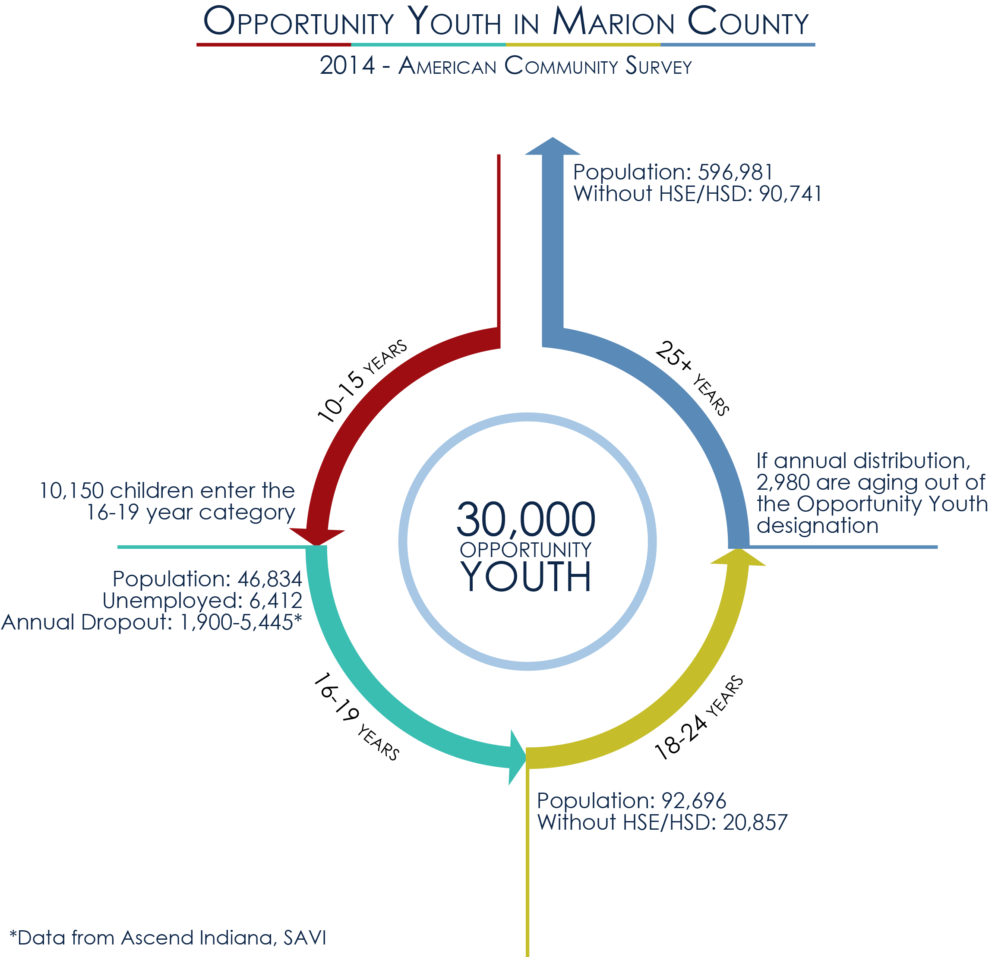

EmployIndy RFP# 2020-003
Attachment B: Marion County Youth Employment System

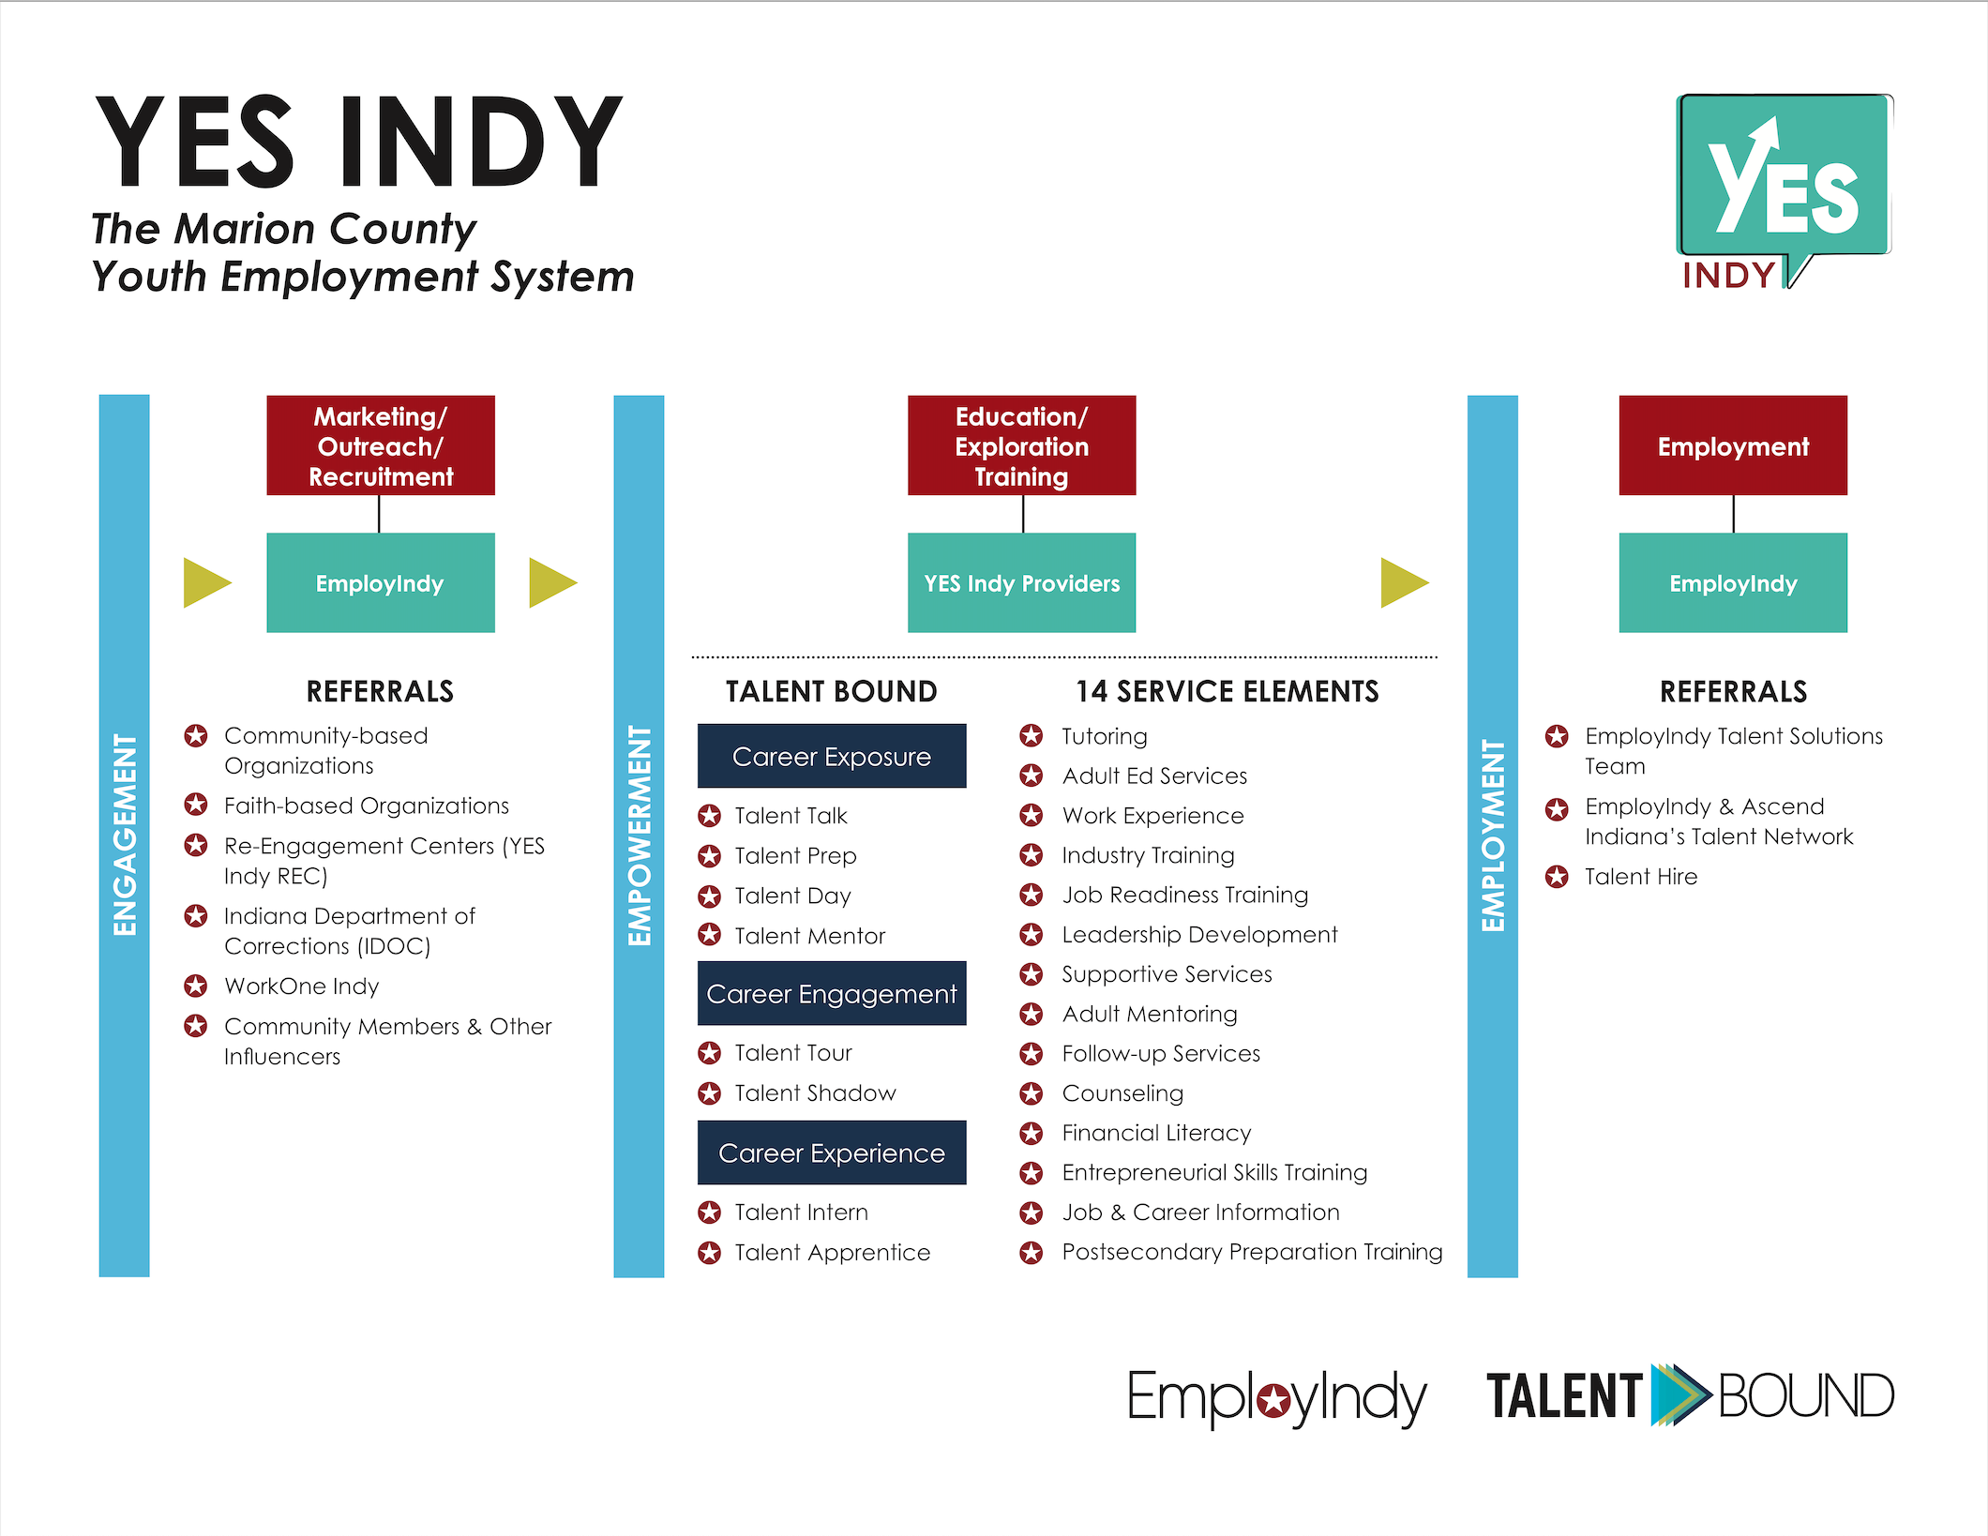

EmployIndy RFP# 2020-003

Attachment C: YES Service Elements Delivery Plan

Please complete the table below and provide as an attachment to the full proposal.

No. | Service Element*  (Identified Element on Attachment B) | Will your organization directly deliver this service?  (Y/N) | Who is your partner for this service?  (Name organization) | Do you have a formal partnership agreement in place? (Y/N)
1. | Tutoring, study skills training, instruction, and evidence-based dropout prevention and recovery strategies that lead to completion of the requirements for a secondary school diploma
2. | Alternative secondary school services, or dropout recovery services, as appropriate  (Adult Ed Services)
3. | Paid and unpaid work experiences that have as a component academic and occupational education. This can include the number of youth who may be placed in an experience through EmployIndy’s Talent Bound efforts.
4. | Occupational skills training  (Industry Training)
5. | Education offered concurrently with and in the same context as workforce preparation activities and training for a specific occupation or occupational cluster  (Job Readiness Training)
6. | Leadership development opportunities
7. | Supportive Services
8. | Adult mentoring face-to-face for the period of participation and a subsequent period, for a total of not less than 12 months
9. | Follow-up services for not less than 12 months after the completion of participation
10. | Comprehensive guidance and counseling
11. | Financial literacy education
12. | Entrepreneurial skills training
13. | Services that provide labor market and employment information about in-demand industry sectors or occupations  (Job & Career Information)
14. | Activities that help youth prepare for and transition to postsecondary education and training

*Refer to Section III.b. for full definition
EmployIndy RFP# 2020-003
Attachment D: WIOA Titles I-IV

Title I: Workforce Development Activities
Title I governs the one-stop delivery system, for which EmployIndy is most directly responsible. The Youth Services Provision falls within this title and mandates fourteen program elements which must be included in the service and design, either through direct services provisions or through a partnership with other organizations, including EmployIndy and WorkOne Indy.

Title I-A requires EmployIndy to engage in regional coordination. The One-Stop Operator is specifically charged with assisting EmployIndy in this coordination.

Title I-B creates in each local region a one-stop delivery system compromised of training and career services programs under Titles II, III, and IV, and other federally required partner programs. Additionally, Title I-B outlines the provision of training services and career services to adults, dislocated workers, out-of-school youth, and in-school youth. In Marion County, training and career service providers are selected through competitive bid processes by EmployIndy.

Title II: Adult Education and Literacy Act
Title II impacts the Adult Education and Literacy Act, which is intended to “create a partnership among the Federal Government, States, and localities to provide, on a voluntary basis, adult education, and literacy activities.” The purpose of Title II is to “assist adults to become literate and obtain the knowledge and skills necessary for employment and economic self-sufficiency.” EmployIndy currently partners with four area adult education and literacy providers receiving
WIOA Title II funds through the DWD Adult Education program. DWD engages in a competitive application process for Adult Education Grants which may change future provider partners.

Title III: Wagner-Peyser Employment Services
Title III of WIOA amends the Wagner-Peyser Act of 1933 which established a nationwide system of public employment offices known as Employment Services. Wagner-Peyser focuses on providing a variety of employment related labor exchange services including but not limited to job search assistance, job referral, and placement assistance for job seekers, re-employment services to unemployment insurance claimants, and recruitment services to employers with job openings.

In Marion County, Wagner-Peyser Employment Services are delivered by DWD state employees that will be functionally managed by the WorkOne Indy Services Provider, as described in more detail throughout this RFP.

Title IV: Rehabilitation Act of 1973
Title IV amends the Rehabilitation Act of 1973 and the provision of vocational rehabilitation services. Based on findings that “individuals with disabilities experience staggering levels of unemployment and poverty,” vocational rehabilitation services are provided to help individuals with disabilities “prepare for, obtain, or retain employment.”

In Marion County, the Vocational Rehabilitation program is implemented by the Indiana Family and Social Services Administration.

EmployIndy RFP# 2020-003

Attachment E: Funding Source Assessment

Please check all that apply and provide as an attachment to the full proposal.

Organization Name: __________________________________________________________

- Is currently funded by Federal formula dollars.
- Currently retains a full-time staff equivalent to review and monitor for quality assurance and/or provide service delivery data entry.
- Has accounting capacity and experience with tracking staff time for delivering client/participant services across multiple funding streams.
- Has had an A-133 audit in the past three years.
- Has previously received Youth Employment Services funds through EmployIndy.
- Has previously been awarded WIOA Youth funds.
- Currently uses one or more of the following systems to enter, manage, and track data for clients/participants:

  - Efforts to Outcomes (ETO)
  - Indiana Career Connect (ICC)

EmployIndy RFP# 2020-003
Attachment F: Projected Outcomes

Please complete the table below and provide as an attachment to the full proposal.

YES Indy
January 1, 2021-December 31, 2021
Key Performance Indicators | Projected Outcome
Number of out-of-school youth and young adults to be served by the organization
Number of out-of-school youth and young adults to enroll in YES Indy services (participants)
Number of participants earning at least 2 Job Ready Indy badges
Number of participants entering post-secondary education
Number of participants entering advanced training
Number of participants receiving Talent Intern, paid or unpaid work experiences, and participating in career-connected learning experiences
Number of participants to obtain a recognized post-secondary credential
Number of participants to complete an advanced training
Number of participants to earn their HSD or HSE
Number of participants placed in unsubsidized employment (A Job Level) [Talent Hire]
Number of participants placed in unsubsidized employment (B or C Job Level) [Talent Hire]
Number of participants who are retained in education or training services or in unsubsidized employment 30 days after placement
Number of participants who are retained in education or training services or in unsubsidized employment 60 days after placement
Number of participants who are retained in education or training services or in unsubsidized employment 90 days after placement
Number of participants who are retained in education or training services or in unsubsidized employment 180 days after placement
Number of participants who are retained in education or training services or in unsubsidized employment 365 days after placement

YES Indy // Talent Bound
January 1, 2021-December 31, 2021
Key Performance Indicators | Projected Outputs
Number of participants who participate in Talent Talk(s)
Number of participants who participate in Talent Prep(s)
Number of participants who participate in Talent Day(s)
Number of participants who participate in Talent Mentor(s)
Number of participants who participate in Talent Tour(s)
Number of participants who participate in Talent Shadow(s)

EmployIndy RFP# 2020-003

Attachment G: Budget Summary

Please complete the worksheet below and provide as an attachment to the full proposal.

YES Indy
January 1, 2021-December 31, 2021
Cost Category | Category Sub-Total
Personnel & Fringe | $
Direct Participant | $
Work Experience | $
Staff Travel and Development | $
Indirect Costs | $
Administrative/Overhead | $
Total Amount Requested | $

EmployIndy RFP# 2020-003

Attachment H: YES Indy Logic Model

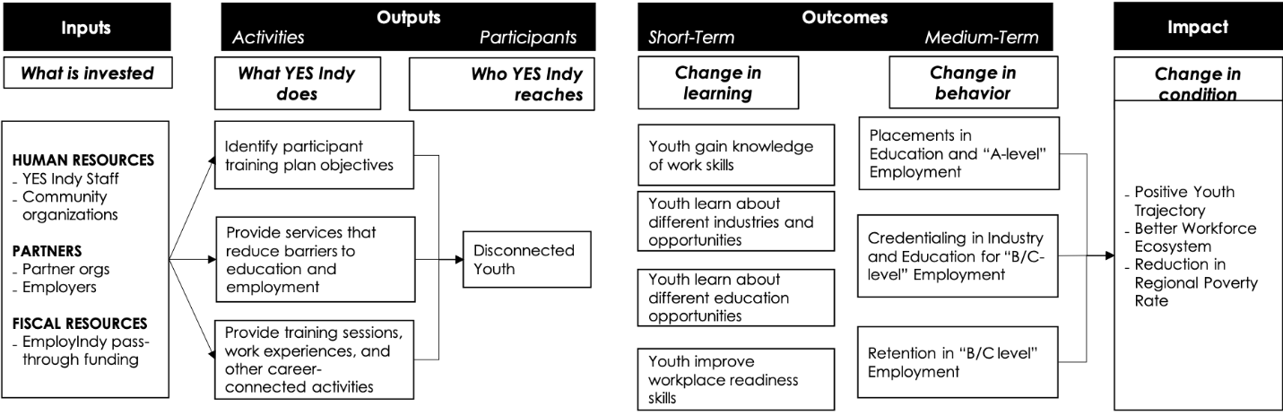

http://www.businessnorth.com/around_the_region/record-high-youth-unemployment-drives-need-for-local-solutions/article_85057a

